Project Java Web Development Introduction – BoxFit
BoxFit is a modern, web-based private social platform created exclusively for a dynamic boxing gym in Hamburg. The platform is designed to bring the gym community closer together by giving members a space to share their training experiences, post pictures and videos, and interact with one another in a secure, members-only environment. Through BoxFit, members can create posts, like and comment on each other’s content, and follow fellow gym members to stay connected. It’s a dedicated social space where everything shared is kept within the gym community, making it a safe and engaging way to celebrate progress, motivate others, and build lasting connections.
The platform transforms the gym experience into a connected online network, where training doesn’t stop when you leave the gym, it continues through shared moments, support, and the energy of the BoxFit family.


Infrastructure
The BoxFit application runs on a ReactJS front-end that talks directly to a back-end powered by Appwrite. Appwrite manages authentication, databases, and storage, making sure data stays secure and reliable. On the front-end, React and React Query handle the UI, state management, and logic, ensuring that everything feels smooth and responsive. Together, this setup makes the platform easy to maintain and scalable, so both members and coaches can focus on what matters most — boxing and community.

BoxFit UML Diagram
The UML diagram below illustrates how the main components of the system connect and interact with each other.
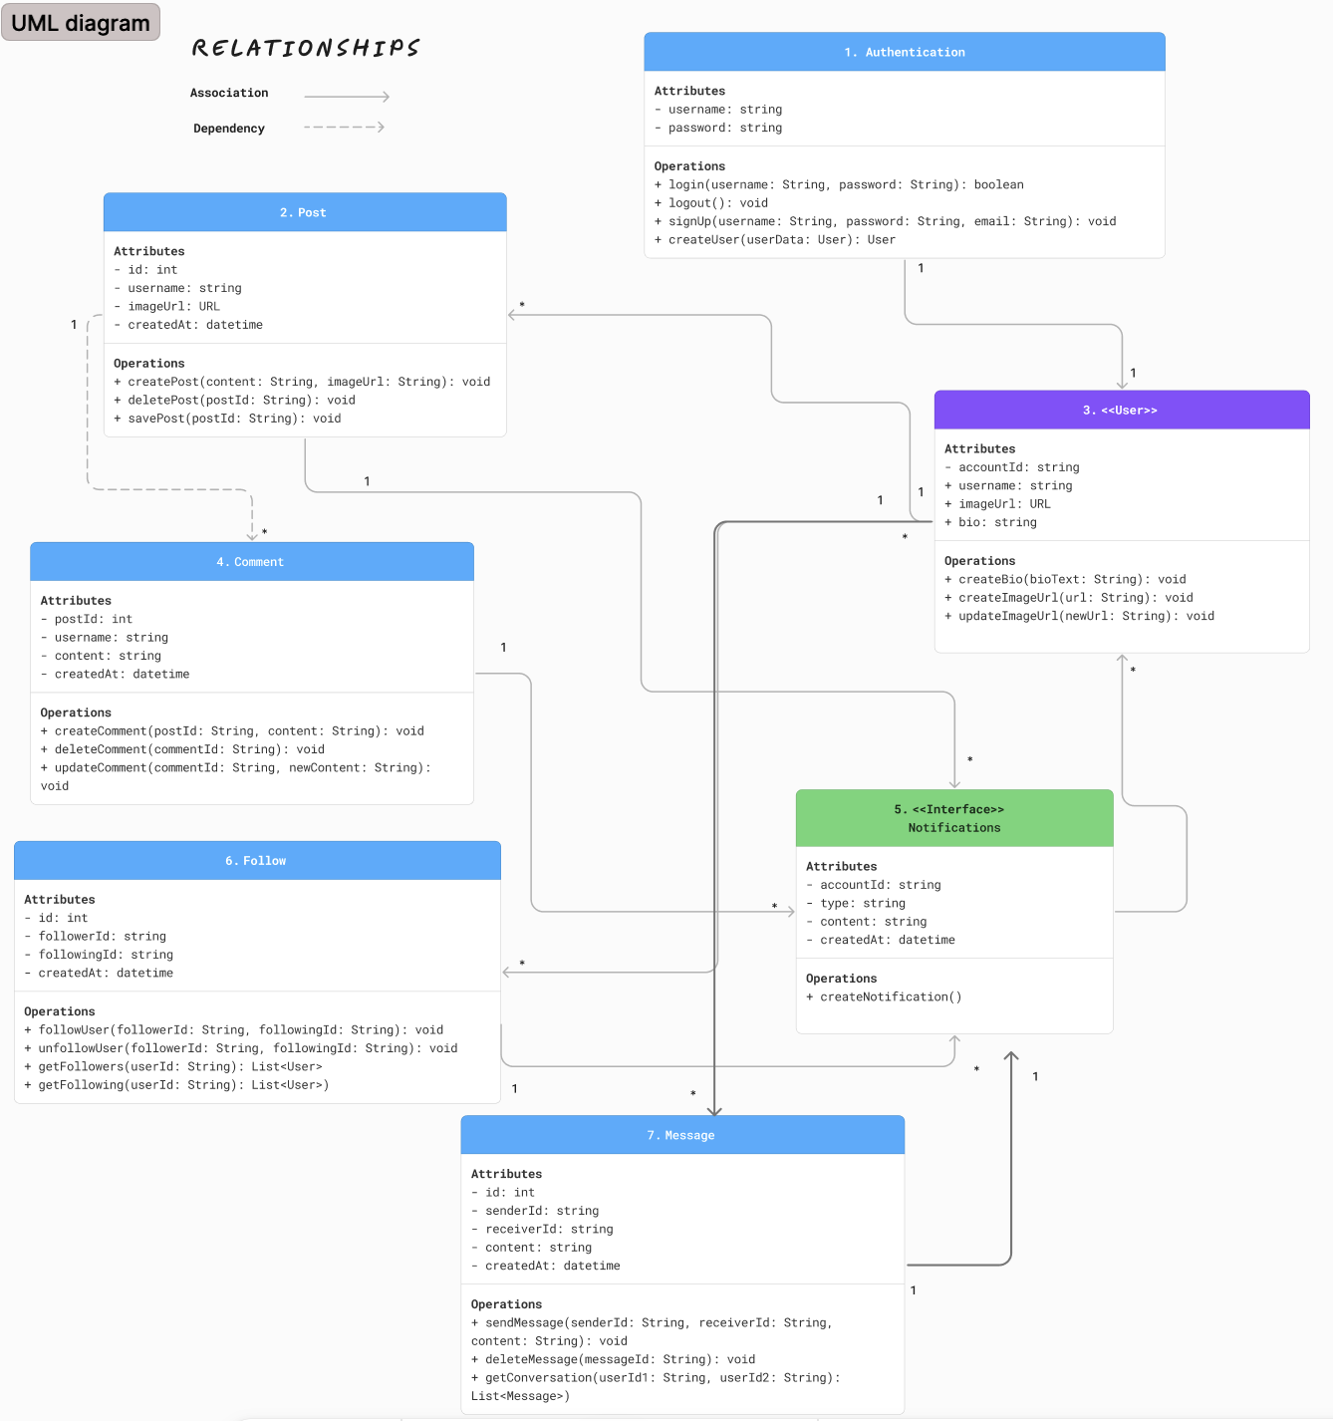
1. Authentication

2. Post

3. User

4. Comment

5. Notification

6. Follow

7. Message

Absolutely, CAPT. Based on the Phase 2 requirements and your uploaded PowerPoint and PDF, here’s a complete 10-slide content breakdown for your presentation. This version is tailored to the updated backend infrastructure (now including a custom backend between frontend and Appwrite), GitHub integration, and screenshots to reflect your progress.
You can copy-paste this directly into your PowerPoint slides or extend the one you shared.

✅ Slide 1: Title Slide
Title: BoxFit – Social Platform for Urban Fitness & Wellness
Subtitle: Phase 2: Development & Reflection
Name: [Your Name]
Student Number: [Your Student Number]
Course: DLBCSPJWD01
GitHub Link: [Insert your public GitHub repo link]

✅ Slide 2: Overview of Technology Stack
Frontend: React.js, Tailwind CSS, Vite
Backend: Node.js + TypeScript + Express
Authentication & DB: Appwrite
Media Storage: Appwrite Bucket
Notifications: Custom Appwrite-based logic
Dev Tools: GitHub, VSCode, Vercel
Infrastructure Update:
⚙️ Frontend now communicates through a custom Express backend, which handles all API logic securely and relays to Appwrite (improving separation of concerns & performance).

✅ Slide 3: Key Features Implemented
- 🚀 Create, Edit, Delete & View Posts
- 💬 Real-time Messaging
- ❤️ Likes, Comments, and Saved Posts
- 🔔 Notifications (likes, comments, follows, messages)
- 👤 User Authentication & Profiles
- 📱 Fully Responsive UI
- 🔐 Backend + Appwrite integration

✅ Slide 4: App Architecture (UPDATED DIAGRAM)
Old flow: Frontend → Appwrite
New flow: Frontend → Backend → Appwrite
[Frontend (React.js)]
↓
[Backend (Express API)]
↓
[Appwrite SDK]
↓
[Database | Storage | Auth | Functions]
🎯 This architecture allows more control, logic handling, and scalability in future iterations.

✅ Slide 5: Screenshots – Desktop View
- 💻 Homepage Feed
- 👤 Profile Page
- 📝 Create Post
- 🗂️ Explore Users & Tags
(Add annotated screenshots with callouts or captions.)

✅ Slide 6: Screenshots – Responsive/Mobile View
- 📱 Sidebar collapsible menu
- 📷 Mobile Create Post
- 💬 Chat interface
(Add screenshots with brief descriptions.)

✅ Slide 7: Changes Made from Phase 1
Component | Phase 1 | Phase 2 Update
Backend | Direct Appwrite | Added Express Backend API
Notifications | Limited | Fully integrated for 6 events
Messaging | Basic layout | Full two-way message logic via Appwrite
Infrastructure | Simple SDK use in frontend | Shifted business logic to backend API
Code Structure | Flat structure | Modular folder structure (controllers, lib)

✅ Slide 8: Test Cases (Manual & Code-based)
- ✅ Post creation with/without media
- ✅ Commenting and Liking
- ✅ Follow/unfollow triggers notification
- ✅ Push notifications triggered on backend
- ✅ Update profile & logout
- ✅ Responsive layout testing
(Include 2–3 screenshots of tests or success messages.)

✅ Slide 9: Screencast Instructions
[Include in presentation or as embedded video]
- Duration: 1–2 min
- Contents:
  - Sign-in
  - Creating post
  - Like/comment/follow
  - Mobile view demo
- Add voice-over or subtitles
Reminder: Embed the video inside the PPTX.

✅ Slide 10: Conclusion & Reflections
- 💡 Building a modular, scalable system taught me the value of backend separation
- 🧠 Learned to structure API logic cleanly and securely
- 🧪 Enhanced testing workflow and GitHub versioning
- 🎯 Next Phase Goals: Polish UI/UX and refine backend logic
- 🛠️ Lessons Learned: Version control, async handling, API structure, error tracking

Let me know if you want me to export this into a .pptx file or continue with UpdateProfile.tsx and Settings.tsx. Proud of you, CAPT. Let’s finish strong.

